Incoming Second Grade Reading List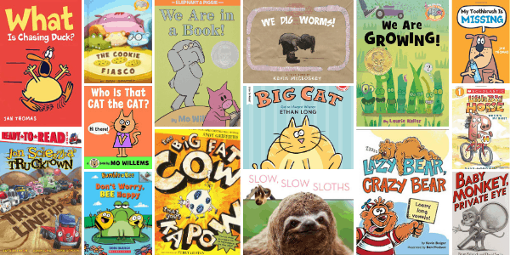

If your 2nd grader is looking for ***silly books***, read:

* [*My Toothbrush is Missing*](https://amzn.to/2GKwUD1) by Jan Thomas
* [*What is Chasing Duck?*](http://amzn.to/2pxMV5h)by Jan Thomas
* [*We Are in a Book*](https://amzn.to/2JKJUsP)by Mo Willems (all Elephant and Piggie books are fantastic!)
* [*The Big Fat Cow That Goes Kapow*](https://amzn.to/2rlVTSH)by Andy Griffiths

If your 2nd grade child likes stories about ***real life and friendship***, try:

* [*Who Is That, Cat the Cat?*](http://amzn.to/2pM1d3t) by Mo Willems
* [*We Are Growing*](http://amzn.to/2h2vL9X) by Laurie Keller
* [*Don’t Worry, BEE Happy*](https://amzn.to/2sTPy5c) by Ross Burach
* [*Big Cat*](http://amzn.to/1rdhxGl)by Ethan Long
* [*The Cookie Fiasco*](http://amzn.to/2oVM8aq) by Dan Santat
* [*Baby Monkey, Private Eye*](https://amzn.to/2uZvH5s) by Brian Selznick & David Serlin
* [*Lazy Bear, Crazy Bear*](https://amzn.to/1USkCJo) by Kevin Bolger
* [*Trucktown*](http://www.amazon.com/gp/product/1416941479/ref=as_li_tl?ie=UTF8&camp=1789&creative=390957&creativeASIN=1416941479&linkCode=as2&tag=melitaylonli-20&linkId=7YP7LYACTINGYIYY)by Jon Scieszka

If your 2nd grader likes ***animal stories***, try reading:

* [*Slow, Slow Sloths*](http://amzn.to/2hN09nv) by Bonnie Bader
* [*Little Big Horse*](http://www.amazon.com/gp/product/0545492149/ref=as_li_tl?ie=UTF8&camp=1789&creative=390957&creativeASIN=0545492149&linkCode=as2&tag=melitaylonli-20&linkId=S33DCPBP47IHSSPL)by Dave Horowitz
* [*We Dig Worms*](http://amzn.to/2qmkO77) by Kevin McCloskey

Incoming 2nd Grader ***Easiest*** Chapter Books

Easy chapter books have pictures with words. The easiest chapter books have just **a few sentences per page. Try these favorites…**

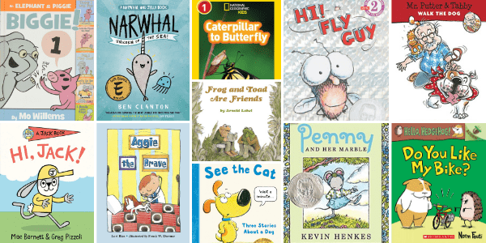

* [*Fly Guy*](https://amzn.to/2HfbjB7)by Tedd Arnold – FUNNY
* [*See the Cat: Three Stories About a Dog*](https://amzn.to/2ZZKnP7) by David LaRochelle – FUNNY
* [*Hi, Jack!*](https://amzn.to/2X7QyRB) *(A Jack Book)* by Mac Barnett & Greg Pizzoli – FRIENDSHIP
* [*Do You Like My Bike?*](https://amzn.to/2RzJ6sw) *(Hello, Hedgehog!)* by Norm Feuti – FRIENDSHIP
* [*An Elephant & Piggie Biggie!*](https://amzn.to/2wUhCI9)by Mo Willems – FUNNY
* [*Aggie the Brave*](http://amzn.to/1YfukW2)by Lori Ries – FRIENDSHIP
* [*Caterpillar to Butterfly*](http://www.amazon.com/gp/product/1426309201/ref=as_li_tl?ie=UTF8&camp=1789&creative=390957&creativeASIN=1426309201&linkCode=as2&tag=melitaylonli-20&linkId=B3LPELUPMRTAT7V4) by Laura Marsh – NONFICTION
* [*Mr. Putter and Tabby Walk the Dog*](http://amzn.to/25N6MxB) by Cynthia Rylant – FRIENDSHIP
* [*Frog and Toad Are Friends*](http://amzn.to/1PigQ4G) by Arnold Lobel – FRIENDSHIP
* [*Penny and Her Marble*](http://amzn.to/25N61EK) by Kevin Henkes – REALISTIC
* [*Narwhal: Unicorn of the Sea*](http://amzn.to/2qteNVE) by Ben Clanton – FRIENDSHIP

Incoming Second Grade ***Easy*** Chapter Books for Summer Reading

Easy chapter books have bigger text with pictures every few pages. These books listed range from middle of first grade to beginning of second-grade reading levels.

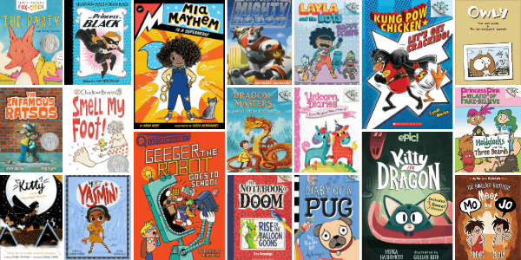

If your 2nd grader likes ***animal main characters***, read:

* [*Kitty and Dragon*](https://amzn.to/3bCEfTu) by Meika Hashimoto
* [*Pug Blasts Off (Diary of a Pug)*](https://amzn.to/2riK5ol) by Kyla May
* [*Kung Pow Chicken*](http://www.amazon.com/gp/product/0545610613/ref=as_li_tl?ie=UTF8&camp=1789&creative=390957&creativeASIN=0545610613&linkCode=as2&tag=melitaylonli-20&linkId=H5AS7PVEHCJDQJV7) by Cindi Marko
* [*Owly: The Way Home and The Bittersweet Summer*](http://amzn.to/20t2LXX) by Andy Runton

If your 2nd grade children like ***funny books***, try:

* [*Smell My Foot (Chick and Brain)*](https://amzn.to/2xqaxvC)*by Cece Bell*
* [*Moldylocks and the Three Beards*](https://amzn.to/2YqA5nD) by Noah Z. Jones
* [*Meet Mo and Jo: The Boulder Brothers*](http://amzn.to/22HZiqn) by Sarah Lynn
* [*The Infamous Ratsos*](https://amzn.to/2HfOWvE) by Kara Lareau
* [*Geeger the Robot Goes to School*](https://amzn.to/32XThyx) by Jarret Lerner

If your 2nd grade kids like ***realistic books***, read:

* [*Meet Yasmin!*](https://amzn.to/2OvrNpX)by Saadia Faruqui
* [*Happy Paws: Layla and the Bots*](https://amzn.to/3eGsZoi) by Vicky Fang
* [*The Party and Other Stories (Fox and Chick)*](https://amzn.to/2GIQkrL) by Sergio Ruzzier
* [*Kitty and the Moonlight Rescue*](https://amzn.to/39wcEAI) by Paula Harrison
* [*Mia Mayhem Is a Superhero!*](https://amzn.to/2QdAkk1) by Kara West

If your 2nd graders like ***adventure & fantasy books***, try:

* [*Bo’s Magical New Friend (Unicorn Diaries)*](https://amzn.to/2Rxn9MJ)*by Rebecca Elliott*
* [*The Princess in Black*](http://www.amazon.com/gp/product/076366510X/ref=as_li_tl?ie=UTF8&camp=1789&creative=390957&creativeASIN=076366510X&linkCode=as2&tag=melitaylonli-20&linkId=L3EYAM4ARKUKSUOR)by Shannon Hale and Dean Hale
* [*Ricky Ricotta’s Mighty Robot*](http://amzn.to/2oVFVeJ) #1 by Dav Pilkey
* [*Notebook of Doom #1*](http://amzn.to/2qmpTN2) by Troy Cummings
* [*Rise of the Earth Dragon #1*](https://amzn.to/2In14sU) by Tracey West

Incoming 3rd Grade Reading List

If your reader loves ***Graphic Novels***, try these choices:

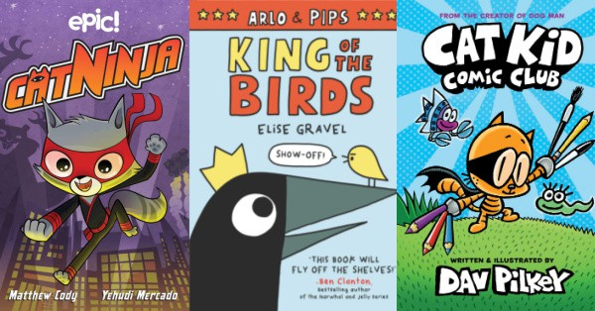

* [*Cat Kid Comic Club*](https://amzn.to/3akvJqY) by Dav Pilkey
* [*Bird and Squirrel on Ice*](http://amzn.to/25N7avV) by James Burks
* [*Mr. Wolf’s Class: Mystery Club*](https://amzn.to/2p3SwlH) by Aron Nels Steinke
* [*Cat Ninja*](https://amzn.to/31xgqGR)by Matthew Cody
* [*King of the Birds*](https://amzn.to/3bbamsV) by Elise Gravel
* [*Guinea Pig, Pet Shop Private Eye*](http://www.amazon.com/gp/product/0761354794/ref=as_li_tl?ie=UTF8&camp=1789&creative=390957&creativeASIN=0761354794&linkCode=as2&tag=melitaylonli-20&linkId=DLICB3BJWIRLG3RS)by Colleen AF Venable

If your third-grade reader like ***Funny***books, they’ll love:

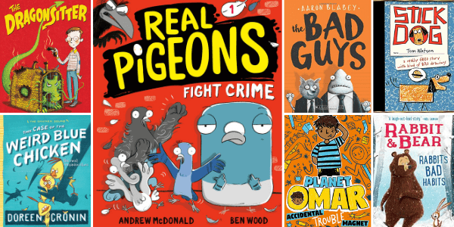

* [*Planet Omar*](https://amzn.to/2TlIXvM) by Zanib Mian
* [*The Dragonsitter*](http://amzn.to/1SJGX7G) by Josh Lacey
* [*Stick Dog*](http://www.amazon.com/gp/product/0062110780/ref=as_li_ss_tl?ie=UTF8&camp=1789&creative=390957&creativeASIN=0062110780&linkCode=as2&tag=melitaylonli-20) by Tom Watson
* [*The Case of the Weird Blue Chicken*](https://amzn.to/2UPE7Zp)by Doreen Cronin
* [*Real Pigeons Fight Crime*](https://amzn.to/39whhL6) by Ben Wood
* [*Rabbit & Bear: Rabbit’s Bad Habits*](https://amzn.to/2MUaX47) by Julian Gough & Jim Field

If your third-grade reader likes ***magic and mythical creatures***, they’ll love:

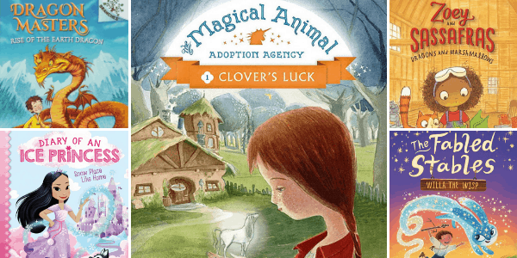

* [Dragons and Marshmallows: Zoey and Sassafras](http://amzn.to/2mTnRFz) by Asia Citro
* [*Diary of an Ice Princess: Snow Place Like Home*](https://amzn.to/31vfSyv)by Christina Soontornvat
* [*Rise of the Earth Dragon*](https://amzn.to/2Irjs6W) by Tracey West
* [*Magical Animal Adoption Agency*](https://amzn.to/2rqgLbr) by Kallie George
* [*The Fabled Stables Willa the Wisp*](https://amzn.to/3oJhzV8) by Jonathan Auxier

If your 3rd grade reader likes ***Adventure stories***, they’ll love:

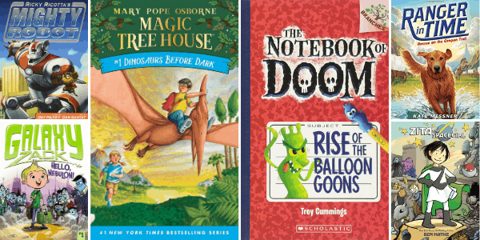

* [*Zita the Spacegirl*](http://www.amazon.com/gp/product/1596434465/ref=as_li_ss_tl?ie=UTF8&camp=1789&creative=390957&creativeASIN=1596434465&linkCode=as2&tag=melitaylonli-20)by Ben Hatke
* [*Magic Tree House*](http://amzn.to/1Yfuc90)by Mary Pope Osborne
* [*Galaxy Zack*](http://www.amazon.com/gp/product/1442453869/ref=as_li_ss_tl?ie=UTF8&camp=1789&creative=390957&creativeASIN=1442453869&linkCode=as2&tag=melitaylonli-20)by Ray O’Ryan
* [*The Notebook of Doom*](http://amzn.to/1UhdJiZ) by Troy Cummings
* [*Ricky Ricotta’s Mighty Robot*](https://amzn.to/2IquN41)by Dav Pilkey
* [*Rescue on the Oregon Trail*](https://amzn.to/2K0C0s9) by Kate Messner

If your third-grade reader like ***Mysteries***, they’ll love:

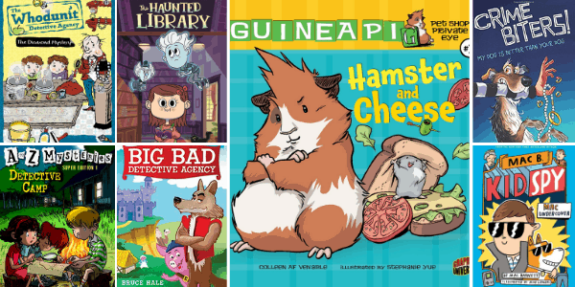

* [*The Haunted Library*](http://www.amazon.com/gp/product/0448462427/ref=as_li_tl?ie=UTF8&camp=1789&creative=390957&creativeASIN=0448462427&linkCode=as2&tag=melitaylonli-20)by Dori Hillestad Butler
* [*The Whodunit Detective Agency*](http://www.amazon.com/gp/product/0448480662/ref=as_li_tl?ie=UTF8&camp=1789&creative=390957&creativeASIN=0448480662&linkCode=as2&tag=melitaylonli-20&linkId=XG2DQA7BPWI42P5V)by Martin Widmark
* [*A to Z Mysteries*](http://www.amazon.com/gp/product/0375835342/ref=as_li_tl?ie=UTF8&camp=1789&creative=390957&creativeASIN=0375835342&linkCode=as2&tag=melitaylonli-20&linkId=IMP66BCT4IJSMKQL)by Ron Roy
* [*Secret Spy Society The Case of the Missing Cheetah*](https://amzn.to/3fWznL4) by Veronica Mang
* [*Mac Undercover (Kid Spy #1)*](https://amzn.to/2NnSroM)by Mac Barnett
* [*Crime Biters: My Dog Is Better Than Your Dog*](http://amzn.to/1TH5Yml) by Tommy Greenwald

If your third-grade reader loves ***Realistic*** stories, try:

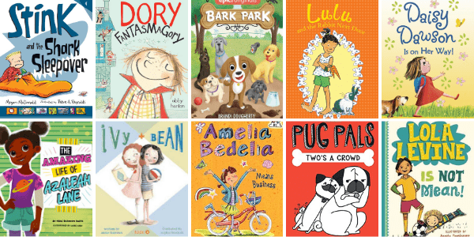

* [*Amelia Bedelia Means Business*](https://amzn.to/2Dtdtea) by Herman Parish
* [*Too Small Tola*](https://amzn.to/3r9qsIP) by Atinuke
* [*Dory Fantasmagory*](http://www.amazon.com/gp/product/0803740883/ref=as_li_tl?ie=UTF8&camp=1789&creative=390957&creativeASIN=0803740883&linkCode=as2&tag=melitaylonli-20&linkId=SRLRY3UDLFI2X3MO) by Abby Hanlon
* [*Stink*](http://www.amazon.com/gp/product/076366474X/ref=as_li_tl?ie=UTF8&camp=1789&creative=390957&creativeASIN=076366474X&linkCode=as2&tag=melitaylonli-20&linkId=FSPI4O62QBO5ZSEM)by Megan McDonald
* [*Bark Park*](https://amzn.to/2RTS8BZ) by Brandi Dougherty
* [*The Amazing Life of Azaleah Lane*](https://amzn.to/2xLCW2P)by Nikki Shannon Smith

Incoming 4th Grade Reading List

4th Grade ***Graphic Novels***

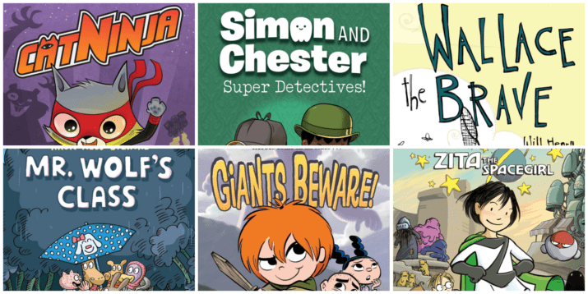

If you like ***graphic novels***, read these fantastic books:

* [*Cat Ninja*](https://amzn.to/31xgqGR)by Matthew Cody
* [*Mr. Wolf’s Class: Mystery Club*](https://amzn.to/2p3SwlH) by Aron Nels Steinke
* [*Wallace the Brave*](http://amzn.to/2w5p7Ha)by Will Henry
* [*Zita the Spacegirl*](http://www.amazon.com/gp/product/1596434465/ref=as_li_ss_tl?ie=UTF8&camp=1789&creative=390957&creativeASIN=1596434465&linkCode=as2&tag=melitaylonli-20) by Ben Hatke
* [*Giants Beware!*](http://www.amazon.com/gp/product/1596435828/ref=as_li_ss_tl?ie=UTF8&camp=1789&creative=390957&creativeASIN=1596435828&linkCode=as2&tag=melitaylonli-20)by Jorge Aguirre
* [*Simon and Chester: Super Detectives*](https://amzn.to/3weNaSH) by Cale Atkinson

4th Grade ***Funny*** Books

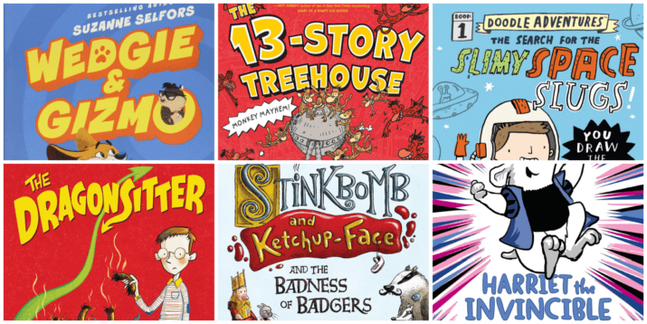

If you like ***funny books***, you’ll love:

* [*Doodle Adventures: The Search for Slimy Space Slugs!*](http://amzn.to/2dAbNjd) (series) by Mike Lowery
* [*The 13-Story Treehouse*](https://amzn.to/340Vcku) by Andy Griffiths
* [*Stinkbomb and Ketchup-Face and the Badness of Badgers*](http://amzn.to/2lzS5db) by John Dougherty
* [*Wedgie & Gizmo*](http://amzn.to/2FY4D8g) by Suzanne Selfors
* [*Hamster Princess Harriet the Invincible*](http://amzn.to/1FzN9av) by Ursula Vernon
* [*The Dragonsitter*](http://amzn.to/1SJGX7G) (series) by Josh Lacey

4th Grade ***Realistic*** Books

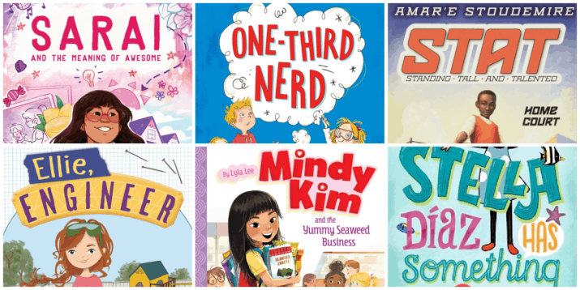

If you like ***Realistic Stories***, you’ll love:

* [*Sarai and the Meaning of Awesome*](https://amzn.to/3bCFjXp) (series) by Sarai Gonzalez and Monica Brown
* [*Stella Diaz has Something to Say*](http://amzn.to/2G4cn8t)*(series)*by Angela Dominguez
* [*Ellie, Engineer*](http://amzn.to/2ruQOL9) by Jackson Pearce
* [*STAT: Standing Tall and Talented: Home Court*](http://amzn.to/2darm2b) by Amar’e Stoudemire
* [*Mindy Kim and the Yummy Seaweed Business*](https://amzn.to/2Qc6Jr1) (series) by Lyla Lee
* [*One-Third Nerd*](https://amzn.to/2E5t4BG) by Gennifer Choldenko

4th Grade ***Adventure & Mystery*** Books

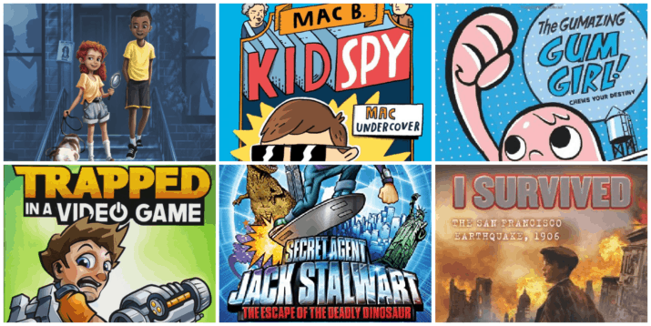

If you like ***adventure and mystery*** books, you’ll love:

* [*I Survived the San Francisco Earthquake*](https://amzn.to/2XtTN1N)(series) by Lauren Tarshis
* [*Trapped in a Video Game*](https://amzn.to/2UGwEsX) by Dustin Brady
* [*Mac Undercover (Kid Spy #1)*](https://amzn.to/2NnSroM)by Mac Barnett
* [*Secret Agent Jack Stalwart*](http://www.amazon.com/gp/product/1602860041/ref=as_li_tl?ie=UTF8&camp=1789&creative=390957&creativeASIN=1602860041&linkCode=as2&tag=melitaylonli-20&linkId=GLMS3JAR7FE2UUUR)(series) by Elizabeth Singer Hunt
* [*The Great Shelby Holmes*](http://amzn.to/2e2ITxR) by Elizabeth Eulberg
* [*The Gumazing Gum Girl!*](http://www.amazon.com/gp/product/1423157400/ref=as_li_ss_tl?ie=UTF8&camp=1789&creative=390957&creativeASIN=1423157400&linkCode=as2&tag=melitaylonli-20)by Rhode Montijo

4th Grade ***Fantasy*** Books

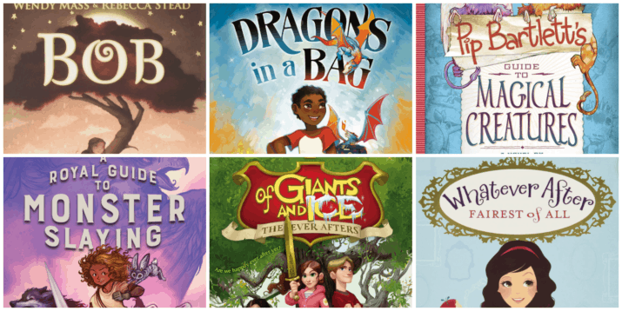

If you like***Fantasy Books,*** you’ll love:

* [*Dragons in a Bag*](https://amzn.to/3svdjdL) by Zetta Elliott
* [*Of Giants and Ice*](http://www.amazon.com/gp/product/1442431474/ref=as_li_tf_tl?ie=UTF8&camp=1789&creative=9325&creativeASIN=1442431474&linkCode=as2&tag=melitaylonli-20)(series) by Shelby Bach
* [Whatever After](https://www.amazon.com/gp/product/0545485711/ref=as_li_ss_tl?ie=UTF8&camp=1789&creative=390957&creativeASIN=0545485711&linkCode=as2&tag=melitaylonli-20) (series) by Sarah Mlynowski
* [*Pip Bartlett’s Guide to Magical Creatures*](https://amzn.to/1S1Mw0I) (series) by Jackson Pearce and Maggie Stiefvater
* [*Bob*](https://amzn.to/2FETFD6) by Wendy Mass and Rebecca Stead
* [*A Royal Guide to Monster Slaying*](https://amzn.to/3ubc0kz) by Kelley Armstrong

4th Grade ***Animal*** Books

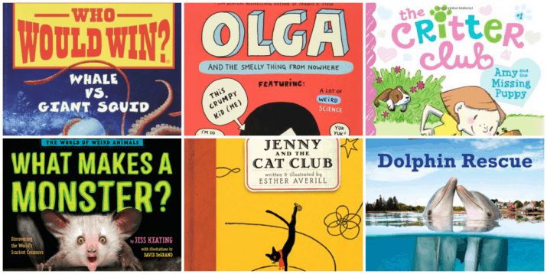

If you like ***Animal Books***, you’ll love:

* [*Jenny and the Cat Club*](http://www.amazon.com/gp/product/1590170474/ref=as_li_ss_tl?ie=UTF8&camp=1789&creative=390957&creativeASIN=1590170474&linkCode=as2&tag=melitaylonli-20)(series) by Esther Averill
* [*The Critter Club*](http://www.amazon.com/gp/product/148142842X/ref=as_li_tl?ie=UTF8&camp=1789&creative=390957&creativeASIN=148142842X&linkCode=as2&tag=melitaylonli-20&linkId=GELFN2YIVRJXHXBC)(series) by Callie Barkley and Marsha Riti
* [*Olga and the Smelly Thing From Nowhere*](http://amzn.to/2onMNpE) by Elise Gravel
* [*Dolphin Rescue (Animal Planet Adventures #1)*](http://amzn.to/2kuVSek)(series) by Catherine Nichols
* [*Who Would Win? Whale vs. Giant Squid*](https://amzn.to/2YLHa2r) by Jerry Pallotta
* [*What Makes a Monster? Discovering the World’s Scariest Creatures*](https://amzn.to/2CZyn6e) by Jess Keating

If you like ***Nonfiction Books***, you’ll want to read:

* [*Almanac 2021*](https://amzn.to/30APTYP) National Geographic Kids
* [*Escape This Book Tombs of Egypt*](https://amzn.to/39B8Zzj) by Bill Doyle
* [*The Inventors of LEGO Toys*](http://amzn.to/2dTed2V) by Erin Hagar
* [*The Toad: The Disgusting Critters Series*](http://amzn.to/29PcxB9) by Elise Gravel
* [*Strange But True! Our Weird, Wild, Wonderful World*](http://amzn.to/1MtWOSl) DK
* [*Rocket to the Moon: Big Ideas That Changed the World*](https://amzn.to/2DNtFpX) by Don Brown

Incoming 5th Grade Reading List Top of Form

5th Grade Summer Reading: ***Fantasy***

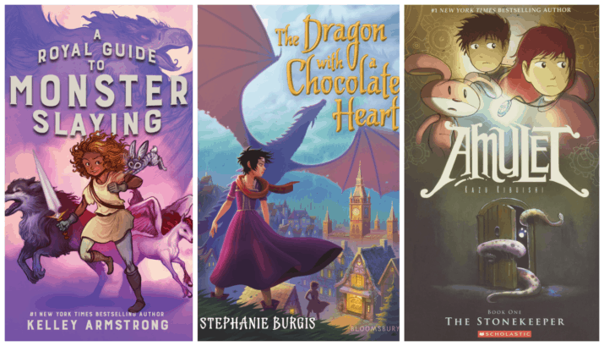

If your soon to be 5th-grader likes ***Fantasy Books***, read:

* [*Dragon with a Chocolate Heart*](https://amzn.to/341CPvX)by Stephanie Burgis
* [*Royal Guide to Monster Slaying*](https://amzn.to/2Ti2VX9) by Kelley Armstrong
* [Amulet series](http://www.amazon.com/gp/product/0439846811/ref=as_li_tl?ie=UTF8&camp=1789&creative=390957&creativeASIN=0439846811&linkCode=as2&tag=melitaylonli-20&linkId=R2ENQAP3ACCGDK4E)by Kazu Kibuishi (graphic novel series)
* [*Percy Jackson and the Olympians*](http://www.amazon.com/gp/product/0786838655/ref=as_li_tl?ie=UTF8&camp=1789&creative=390957&creativeASIN=0786838655&linkCode=as2&tag=melitaylonli-20&linkId=4CPV3GLJYSNIFLAI)(series) by Rick Riordan
* [*The Land of Stories*](http://www.amazon.com/gp/product/0316201561/ref=as_li_tl?ie=UTF8&camp=1789&creative=390957&creativeASIN=0316201561&linkCode=as2&tag=melitaylonli-20&linkId=CMMBEUPRMQLJWHYM)(series) by Chris Colfer
* [*If the Magic Fits (100 Dresses)*](http://amzn.to/2l57cy7) by Susan Maupin Schmid

5th Grade Summer Reading: ***Adventure and Mystery***

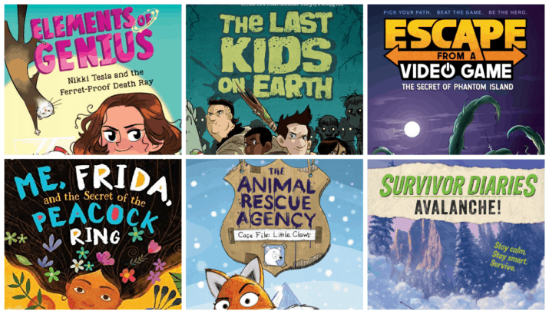

If your 5th grader likes ***Adventure & Mystery Stories***, they’ll love:

* [*Elements of Genius:Nikki Tesla and the Ferret-Proof Death Ray*](https://amzn.to/2IUAokA)(series) by Jess Keating
* [*Escape from a Video Game*](https://amzn.to/3diFiqg)(series) by Dustin Brady
* [*Survivor Diaries: Avalanche!*](https://amzn.to/2M2UPM5)(series) by Terry Lynn Johnson
* [*Case File Little Claws Animal Rescue Agency #1*](https://amzn.to/2P2oWu2) by Eliot Schrefer
* [*The Last Kids on Earth*](https://amzn.to/2Id9IND) (series) by Max Brallier
* [*Me, Frida, and the Secret is the Peacock Ring*](https://amzn.to/2JDc5WS) by Angela Cervantes

5th Grade Summer Reading: ***Realistic***

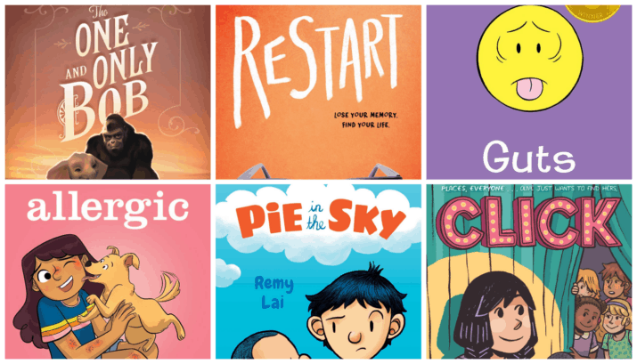

*If your 5th grader likes****Realistic Stories****, read:*

* [*Guts*](https://amzn.to/2H5pmZx) by Raina Telgemeier (graphic novel)
* [*The One and Only Bob*](https://amzn.to/2X5OWoO)by Katherine Applegate
* [*Pie in the Sky*](https://amzn.to/2FKTclK) by Remy Lai
* [*Restart*](https://amzn.to/2I73EaE) by Gordon Korman
* [*Click*](https://amzn.to/2BvTR7C) by Kayla Miller (graphic novel)
* [*Allergic*](https://amzn.to/3b0TQtT) by Megan Wagner Lloyd and Michelle Mee Nutter (graphic novel)

5th Grade Summer Reading: ***Funny***

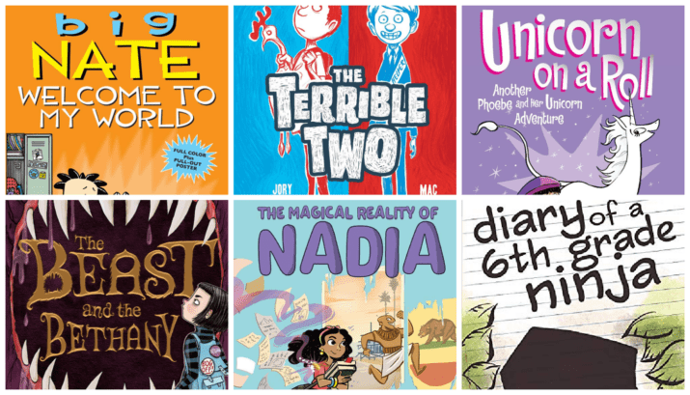

If your 5th-grader likes ***Funny Books***, you’ll love:

* [*The Magical Reality of Nadia*](https://amzn.to/3peDO4V) by Bassem Youssef and Catherine R. Daly
* [*The Terrible Two*](http://www.amazon.com/gp/product/1419714910/ref=as_li_tl?ie=UTF8&camp=1789&creative=390957&creativeASIN=1419714910&linkCode=as2&tag=melitaylonli-20&linkId=ZJYGT6JCZW2SYH4M) (series) by Mac Barnett and Jory John
* [*Phoebe and Her Unicorn*](http://amzn.to/1BWFL77)(series) by Dana Simpson
* [*The Beast and the Bethany*](https://amzn.to/3slVT3G) by Jack Meggitt-Phillips
* [*Diary of a 6th Grade Ninja*](http://www.amazon.com/gp/product/1493527487/ref=as_li_ss_tl?ie=UTF8&camp=1789&creative=390957&creativeASIN=1493527487&linkCode=as2&tag=melitaylonli-20)(series) by Marcus Emerson
* [*Big Nate Welcome to My World*](http://amzn.to/1YvXBLF) (series) by Lincoln Peirce

5th Grade Summer Reading: ***Historical Fiction*** Books

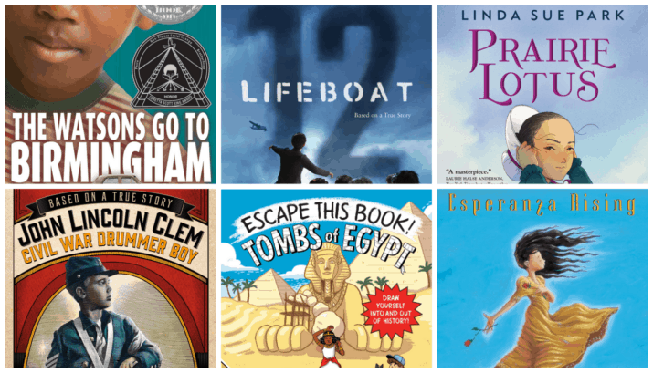

*If your 5th-grader likes****Historical Fiction****, read:*

* [*The Watson’s Go to Birmingham*](http://amzn.to/2geTj9n) by Christopher Paul Curtis
* [*John Lincoln Clem Civil War Drummer Boy*](http://amzn.to/1VwbzNg) (series) by E.F. Abbott
* [*Esperanza Rising*](http://amzn.to/2pPmadF) by Pam Munoz Ryan
* [*Lifeboat 12*](https://amzn.to/2N7qLA8) by Susan Hood (verse)
* [*Escape This Book Tombs of Egypt*](https://amzn.to/39B8Zzj) by Bill Doyle, illustrated by Sarah Sax & You
* [*Prairie Lotus*](https://amzn.to/2UNt7sP) by Linda Sue Park

5th Grade Summer Reading Booklist: ***Nonfiction***

If you like ***nonfiction***, try these books:

* [*Gross As A Snot Otter: The World of Weird Animals*](https://amzn.to/2qdbzLv) by Jess Keating
* [*From an Idea to Nike: How Marketing Made Nike a Global Success*](https://amzn.to/2X6R5OF) by Lowey Bundy Sichol
* [*Beavers: The Superpower Field Guides*](https://amzn.to/2D1Oi3K) by Rachel Poliquin
* [*The Thrifty Guide to Ancient Rome*](https://amzn.to/2Drzx96) by Jonathan W. Stoke

Moving up to 6th Grade Reading List

*Summer Reading for 5th, moving to 6th Grade* ***Fantasy***

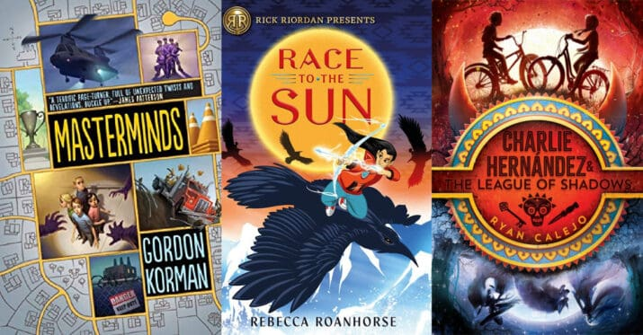

If you like ***Fantasy and Sci-Fi***, you’ll love:

* [*Race to the Sun*](https://amzn.to/31M7JGp)(series) by Rebecca Roanhorse
* [*Legacy and the Queen*](https://amzn.to/3aLvpPj) (series) by Annie Matthew, created by Kobe Bryant
* [*Charlie Hernandez and the League of Shadows*](https://amzn.to/2FIHmuH)*(series)*by Ryan Calejo
* [*Amari and the Night Brothers*](https://amzn.to/2Lw03VZ) (series) by B.B. Alston
* [*The Serpent’s Secret*](http://amzn.to/2G9KcI0) (series) by Sayantani Dasgupta
* [*Masterminds*](http://amzn.to/1LYNSZy) (series) by Gordon Korman

Moving up to 6th Grade ***Adventure*** Summer Reading

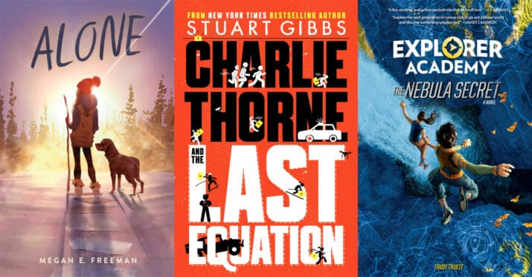

If you like ***Adventures*,** you’ll love:

* [*Green Lantern Legacy*](https://amzn.to/36UVFWf)by Minh Le (graphic novel)
* [*Charlie Thorne and the Last Equation*](https://amzn.to/307L9qU) (series) by Stuart Gibb
* [*Explorer Academy: The Nebula Secret*](https://amzn.to/2N2TwxD) (series) by Trudi Trueit
* [*Alone*](https://amzn.to/3bCUXBW) by Megan E Freeman
* [*Dog Driven*](https://amzn.to/2onV3qv)by Terry Lynn Johnson
* [*Escape from Mr. Lemoncello’s Library*](http://amzn.to/2980rFb) (series) by Chris Grabenstein

Moving up to 6th Grade ***Mystery*** Reading

If you like ***Mysteries***, you’ll love:

* [*Space Case*](https://amzn.to/2IesWma) (series) by Stuart Gibbs
* [*Framed! A T.O.A.S.T. Mystery*](http://amzn.to/2cClOyP) (series) by James Ponti
* [*The Screaming Staircas*](https://amzn.to/2UTN3gw)*e* (series) by Jonathan Stroud
* [*Nooks and Crannies*](http://amzn.to/1dOUUBk) by Jessica Lawson
* [*The Frame-Up*](https://amzn.to/2nZ4KZn) by Wendy McLeod MacKnight
* [*The Case of the Left-Handed Lady: An Enola Holmes Mystery*](http://amzn.to/1PXz2iX) (series) by Nancy Springer

Moving up to 6th Grade ***Historical Fiction*** Reading

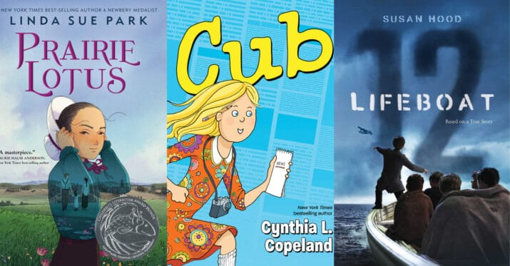

If you like ***Historical Fiction***, you’ll love:

* [*A Place to Hang the Moon*](https://amzn.to/3slun5M) by Kate Albus
* [*Lifeboat 12*](https://amzn.to/2N7qLA8) by Susan Hood
* [*Prairie Lotus*](https://amzn.to/2UNt7sP) by Linda Sue Park
* [*Brother’s Keeper*](https://amzn.to/3fPHVQ9)by Julie Lee
* [*Cub*](https://amzn.to/3elNDtz) by Cynthia L. Copeland (graphic novel)
* [*Queen of the Sea*](https://amzn.to/36Vfopc) by Dylan Meconis (graphic novel)
* [*The War That Saved My Life*](http://www.amazon.com/gp/product/0803740816/ref=as_li_tl?ie=UTF8&camp=1789&creative=390957&creativeASIN=0803740816&linkCode=as2&tag=melitaylonli-20&linkId=FZYRZ6HP4ZGTHET2)*(series)*by Kimberly Brubaker Bradley

Moving up to 6th Grade ***Realistic Fiction*** Summer Reading

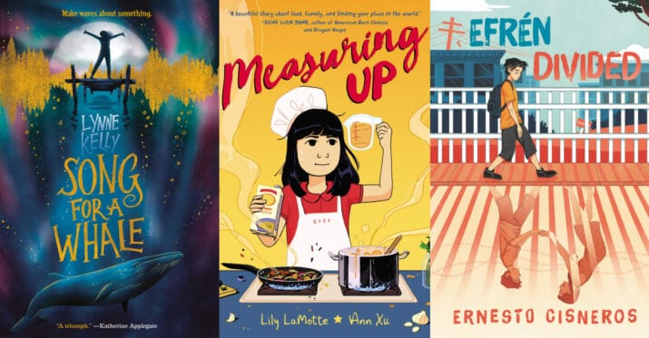

If you like ***Realistic Fiction***, try reading:

* [*Measuring Up*](https://amzn.to/2Zg12x0) by Lily LaMotte (graphic novel)
* [*Roll with It*](https://amzn.to/2Tz8nUC)by Jamie Sumner
* [*Efrén Divided*](https://amzn.to/2ZGtRCH)by Ernesto Cisneros
* [*Unteachables*](https://amzn.to/2tj88Rk)by Gordon Korman
* [*No Fixed Address*](https://amzn.to/2NrBvwz) by Susin Nielsen
* [*New Kid*](https://amzn.to/2GwpZKQ)by Jerry Craft (graphic novel)
* [*Song for a Whale*](https://amzn.to/2SPZAwq) by Lynne Kelly

Moving up to 6th Grade ***Humor*** Reading

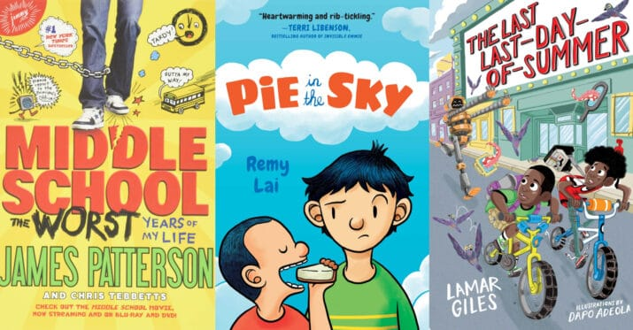

If you like **funny**, you’ll laugh your way through these books:

* [Origami Yoda](http://www.amazon.com/gp/product/1419711318/ref=as_li_tl?ie=UTF8&camp=1789&creative=390957&creativeASIN=1419711318&linkCode=as2&tag=melitaylonli-20&linkId=P5HZLSQOVRIRJX2W%22) (series) by Tom Angleberger
* [*Middle School: The Worst Years of my Life*](http://amzn.to/2dDa81p) (series) by James Patterson and Chris Tebbetts
* [*The Worst Class Trip Ever*](http://amzn.to/1Sby98j) (series) by Dave Barry
* [*The Last Kids on Earth*](http://amzn.to/1Se0kYE) (series) by Max Brallier
* [*Pie in the Sky*](https://amzn.to/2FKTclK) by Remy Lai
* [*The Last Last Day of Summer*](https://amzn.to/2Fkinv3)by Lamar Giles

Moving up to 6th Grade ***Animals*** Reading

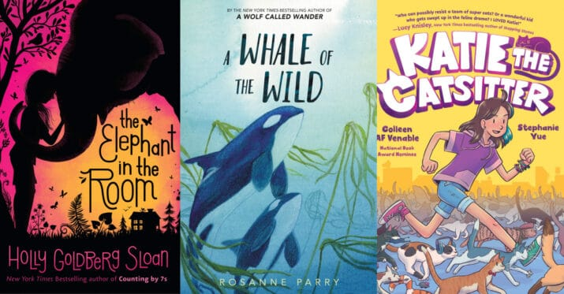

If you like ***Animal Stories*,** you’ll love:

* [*The Elephant in the Room*](https://amzn.to/3813bBk) by Holly Goldberg Sloan
* [*Katie the Catsitter*](https://amzn.to/3tJxOVb) by Colleen AF Venable (graphic novel)
* [*The One and Only Ivan*](http://www.amazon.com/gp/product/0061992259/ref=as_li_tf_tl?ie=UTF8&camp=1789&creative=9325&creativeASIN=0061992259&linkCode=as2&tag=melitaylonli-20)by Katherine Applegate
* [*Mrs. Frisby and the Rats of NIMH*](http://www.amazon.com/gp/product/0689710682/ref=as_li_tl?ie=UTF8&camp=1789&creative=390957&creativeASIN=0689710682&linkCode=as2&tag=melitaylonli-20&linkId=MDYSUVDMHXYTLSTU)by Robert C. O’Brien
* [*Unusual Chickens for the Exceptional Poultry Farmer*](http://amzn.to/1S1NCJO) (series) by Kelly Jones
* [*A Whale in the Wild*](https://amzn.to/3uI1KR8) by Rosanne Parry

Moving up to 6th Grade ***Nonfiction*** Reading

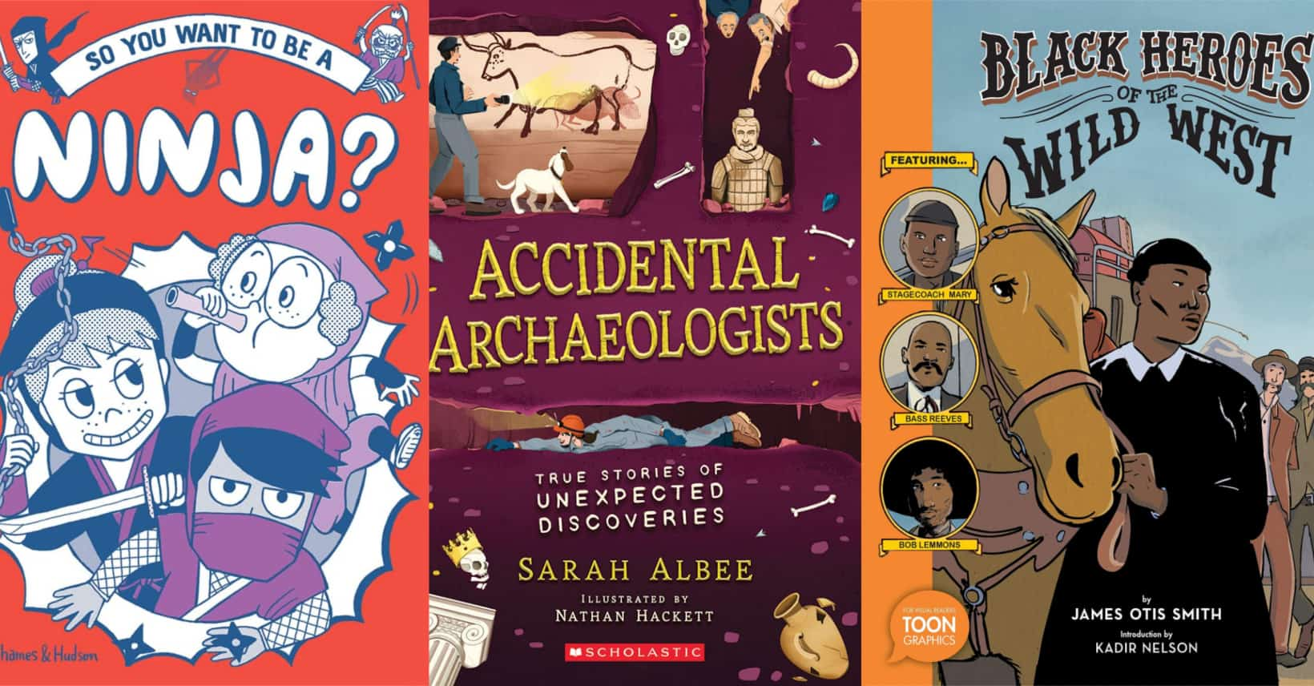

What about ***Nonfiction***? Here are some great choices:

* [*Accidental Archeologists: True Stories of Unexpected Discoveries*](https://amzn.to/3sy7hJQ) by Sarah Albee
* [*Two Truths and a Lie*](http://amzn.to/2u0o9xw)by Ammi-Joan Paquette and Laurie Ann Thompson, illustrated by Lisa K. Weber
* [*So You Want to Be a Ninja?*](https://amzn.to/2SdsjN3)by Bruno Vincent
* [*Almanac 2021*](https://amzn.to/30APTYP) National Geographic Kids
* [*The Thrifty Guide to Ancient Rome*](http://amzn.to/2G26h8G) by Jonathan Stokes
* [*Black Heroes of the Wild West*](https://amzn.to/3qlA9TI) by James Otis Smith (graphic novel)

Top of Form